COLLEGE OF COMPUTER STUDIES AND MULTIMEDIA ARTS

IT0049
(WEB SYSTEM TECHNOLOGIES)

TECHNICAL FORMATIVE ASSESSMENT
2

FROM ARRAYS TO A REAL DATABASE

Student Name / Group Name: | Angelo Kacey N. Pineda
Members (if Group):
  Name | Role
Section: | TW33
Professor: | Sir Von
PROGRAM OUTCOME/S (PO) ADDRESSED BY THE LABORATORY EXERCISE
- Design, implement and evaluate computer-based systems or applications to meet desired needs and requirements. [PO: C]

COURSE LEARNING OUTCOME/S (CLO) ADDRESSED BY THE LABORATORY EXERCISE
- Apply advanced web development principles in creating, debugging, validating, and securing database-backed web applications. [CLO: 2]

INTENDED LEARNING OUTCOME/S (ILO) OF THE LABORATORY EXERCISE
At the end of this exercise, students must be able to:
- Configure CodeIgniter's database connection settings.
- Create a MySQL database and tables using a provided schema.
- Build CodeIgniter Models for the Customer Accounts and User Accounts pages.
- Retrieve records with Query Builder and display them in a view.

BACKGROUND INFORMATION
The POS application from the previous activity stored its data in static PHP arrays, which reset every time the server restarts. This activity replaces that temporary storage with a real MySQL database. CodeIgniter's Model class wraps a database table and gives you Query Builder methods — such as findAll() — for retrieving records without writing raw SQL.
A good rule for this activity: once a page's data comes from a Model, its controller and view code should look almost identical to the static-array version. Only where the data comes from changes.

GRADING SYSTEM / RUBRIC
CRITERIA | Description
Functionality & Requirements Completeness (40 points max) | All required pages and features are present and work as specified in the activity instructions.
Code Structure & Organization (25 points max) | Controllers, models, and views are separated correctly and follow the framework's conventions; code is readable and sensibly named.
Database Design & Query Usage (20 points max) | The database and tables match the provided schema, records are retrieved through a Model using Query Builder (not raw SQL), and the results display correctly in the view.
Documentation & Submission Quality (15 points max) | The GitHub repository is organized and complete, the README explains how to set up and run the project, and the hosted link is live and matches the submitted code.

LABORATORY ACTIVITY
You will extend the POS application from TFA1 by replacing its static arrays with a real MySQL database. Use the schema below.
- Configure your CodeIgniter .env database settings to connect to a local MySQL database.
- Create the database and the customers and users tables using the schema below:
CREATE TABLE customers (
id INT AUTO_INCREMENT PRIMARY KEY,
full_name VARCHAR(100) NOT NULL,
email VARCHAR(100) NOT NULL,
phone VARCHAR(20),
created_at DATETIME NOT NULL
);

CREATE TABLE users (
id INT AUTO_INCREMENT PRIMARY KEY,
username VARCHAR(50) NOT NULL UNIQUE,
full_name VARCHAR(100) NOT NULL,
created_at DATETIME NOT NULL
);

- Populate each table with at least 5 sample records.
- Create a CustomerModel and a UserModel.
- Update your Customer Accounts and User Accounts controllers to retrieve records through their Models instead of static arrays.
- Confirm the views display the retrieved database records the same way they displayed the static array data in TFA1.

Submission Requirements:
- A link to a GitHub repository containing your raw project files, including your database export.
- A link to your hosted, working version of the application.

REFERENCES
- Manfield, A. (2021). Pro CodeIgniter: Learn how to create professional web-applications with PHP.
- CodeIgniter User Guide. Models. https://codeigniter4.github.io/userguide/models/model.html
- CodeIgniter User Guide. Query Builder. https://codeigniter4.github.io/userguide/database/query_builder.html

Database Integration Implementation
IT0049 Technical Formative Assessment 2
This implementation continues the existing SimplePOS CodeIgniter 4 website. It connects CodeIgniter to the existing pos_database database, adds CustomerModel and UserModel, replaces both static arrays with Model queries, and exports the working database for repository submission.
GitHub repository: https://github.com/Angelowww11/TA1_CodeIgniter

Database Schema Used
The implementation uses the corrected account schema prepared for the preceding AI-reviewed database activity. These table names and fields are more detailed than the simplified example in the activity sheet, while still supporting the same Customer Accounts and User Accounts views.

Customer Accounts Table
Field | Data Type | Constraint or Purpose
customer_id | INT UNSIGNED | Primary key and auto increment
first_name | VARCHAR(50) | Required customer first name
last_name | VARCHAR(50) | Required customer last name
email | VARCHAR(100) | Required and unique
phone | VARCHAR(20) | Required and preserves leading zero
address | VARCHAR(255) | Optional address
account_status | VARCHAR(20) | Required with Active default
created_at | DATETIME | Required with current timestamp default

User Accounts Table
Field | Data Type | Constraint or Purpose
user_id | INT UNSIGNED | Primary key and auto increment
username | VARCHAR(50) | Required and unique
password_hash | VARCHAR(255) | Required password hash storage
first_name | VARCHAR(50) | Required staff first name
last_name | VARCHAR(50) | Required staff last name
email | VARCHAR(100) | Required and unique
role | VARCHAR(20) | Required staff role
account_status | VARCHAR(20) | Required with Active default
created_at | DATETIME | Required with current timestamp default

Sample Database Records

Five Customer Records
ID | Customer | Email | Phone | Status
1 | Juan Dela Cruz | juan@example.com | 09171234567 | Active
2 | Maria Santos | maria@example.com | 09181234567 | Active
3 | Carlo Reyes | carlo@example.com | 09191234567 | Active
4 | Ana Garcia | ana@example.com | 09201234567 | Inactive
5 | Luis Mendoza | luis@example.com | 09211234567 | Active

Five User and Staff Records
ID | Username | Staff Name | Role | Status
1 | admin01 | John Admin | Admin | Active
2 | cashier01 | Ella Cruz | Cashier | Active
3 | cashier02 | Mark Tan | Cashier | Active
4 | manager01 | Sofia Lim | Manager | Active
5 | cashier03 | Paul Ramos | Cashier | Inactive

XAMPP and SQL Requirement
No SQL needs to be pasted into phpMyAdmin on the current computer because pos_database, customer_accounts, user_accounts, and all ten sample records already exist and were successfully queried.
For a different computer, repository reviewer, or clean XAMPP installation, start Apache and MySQL, open phpMyAdmin, choose Import, and select database/pos_database.sql. Importing the file creates the database, both tables, their keys and constraints, and the sample records automatically.

CodeIgniter Database Connection
The project .env file contains the local XAMPP connection settings below.
database.default.hostname = 127.0.0.1
database.default.database = pos_database
database.default.username = root
database.default.password =
database.default.DBDriver = MySQLi
database.default.DBPrefix =
database.default.port = 3306

CodeIgniter Models
Each Model identifies its MySQL table, primary key, return type, and allowed fields.

CustomerModel
<?php

namespace App\Models;

use CodeIgniter\Model;

class CustomerModel extends Model
{
protected $table = 'customer_accounts';
protected $primaryKey = 'customer_id';
protected $returnType = 'array';
protected $useAutoIncrement = true;
protected $allowedFields = [
'first_name', 'last_name', 'email', 'phone',
'address', 'account_status',
];
}

UserModel
<?php

namespace App\Models;

use CodeIgniter\Model;

class UserModel extends Model
{
protected $table = 'user_accounts';
protected $primaryKey = 'user_id';
protected $returnType = 'array';
protected $useAutoIncrement = true;
protected $allowedFields = [
'username', 'password_hash', 'first_name', 'last_name',
'email', 'role', 'account_status',
];
}

Short Reflection
In this activity, I learned how to replace static PHP arrays with records from a MySQL database using CodeIgniter 4 Models and Query Builder. I also understood how the database, model, controller, and view work together to display customer and user accounts. This made the POS application more practical because its records are now stored permanently.

Controller Queries
The controllers use Model methods backed by Query Builder. CONCAT creates the full_name value expected by the existing views, so the TFA1 page structure remains familiar.

Customers Controller Query
$customerModel = new CustomerModel();
$customers = $customerModel
->select("CONCAT(first_name, ' ', last_name) AS full_name", false)
->select('email, phone, account_status')
->orderBy('customer_id', 'ASC')
->findAll();

Users Controller Query
$userModel = new UserModel();
$users = $userModel
->select('username')
->select("CONCAT(first_name, ' ', last_name) AS full_name", false)
->select('role, account_status')
->orderBy('user_id', 'ASC')
->findAll();

View Integration
The existing foreach loops are retained. The views now receive Model results and escape every displayed value with esc(). The customer page shows name, email, phone, and status. The user page shows username, name, role, and status. The password_hash field is never selected or displayed.

Customer View Loop
<?php foreach ($customers as $customer): ?>
<tr>
<td><?= esc($customer['full_name']) ?></td>
<td><?= esc($customer['email']) ?></td>
<td><?= esc($customer['phone']) ?></td>
<td><?= esc($customer['account_status']) ?></td>
</tr>
<?php endforeach ?>

User View Loop
<?php foreach ($users as $user): ?>
<tr>
<td><?= esc($user['username']) ?></td>
<td><?= esc($user['full_name']) ?></td>
<td><?= esc($user['role']) ?></td>
<td><?= esc($user['account_status']) ?></td>
</tr>
<?php endforeach ?>

Website Verification Screenshots
The screenshots below were captured from the completed application while CodeIgniter and the XAMPP MySQL service were running locally.
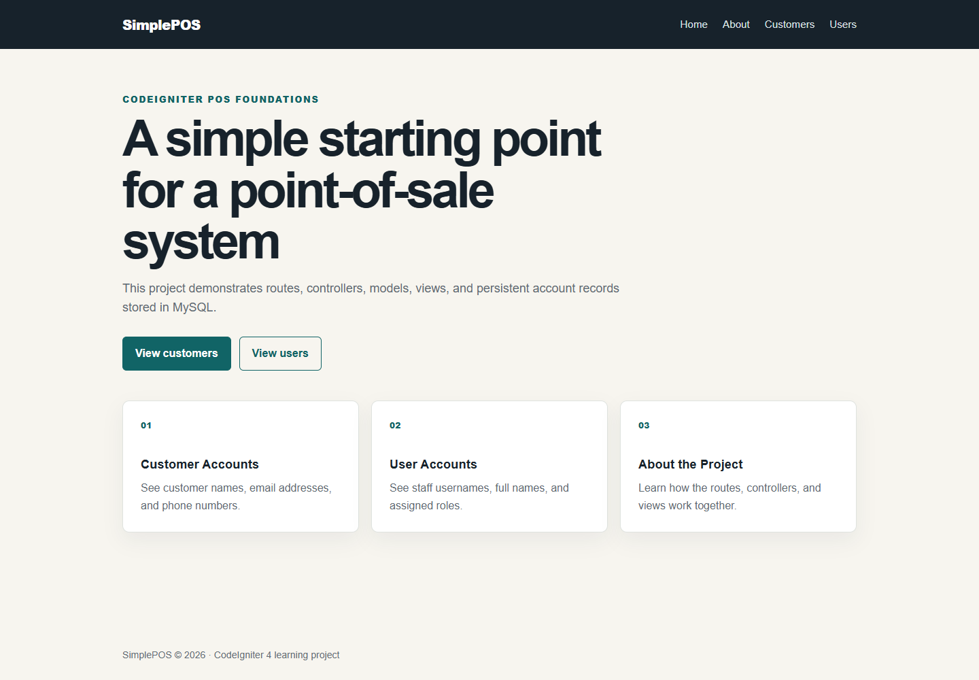
Figure 1 SimplePOS home page after database integration

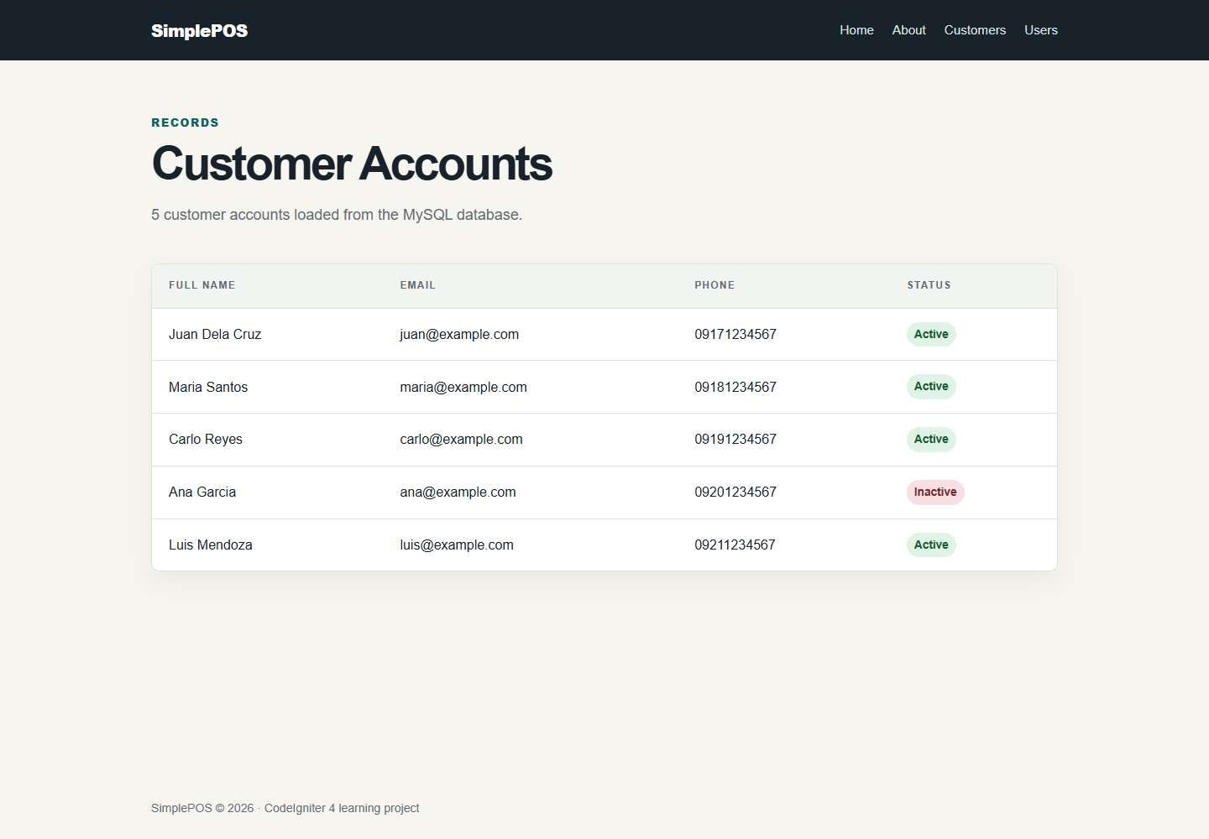
Figure 2 Customer Accounts view showing five MySQL records

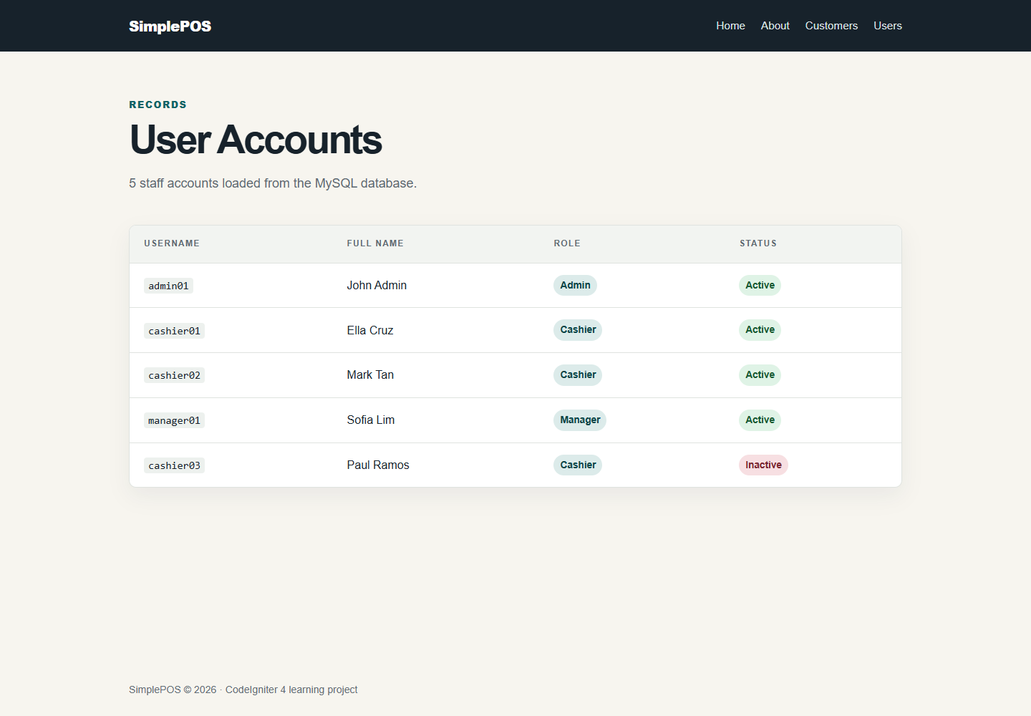
Figure 3 User Accounts view showing five MySQL records

Database Evidence
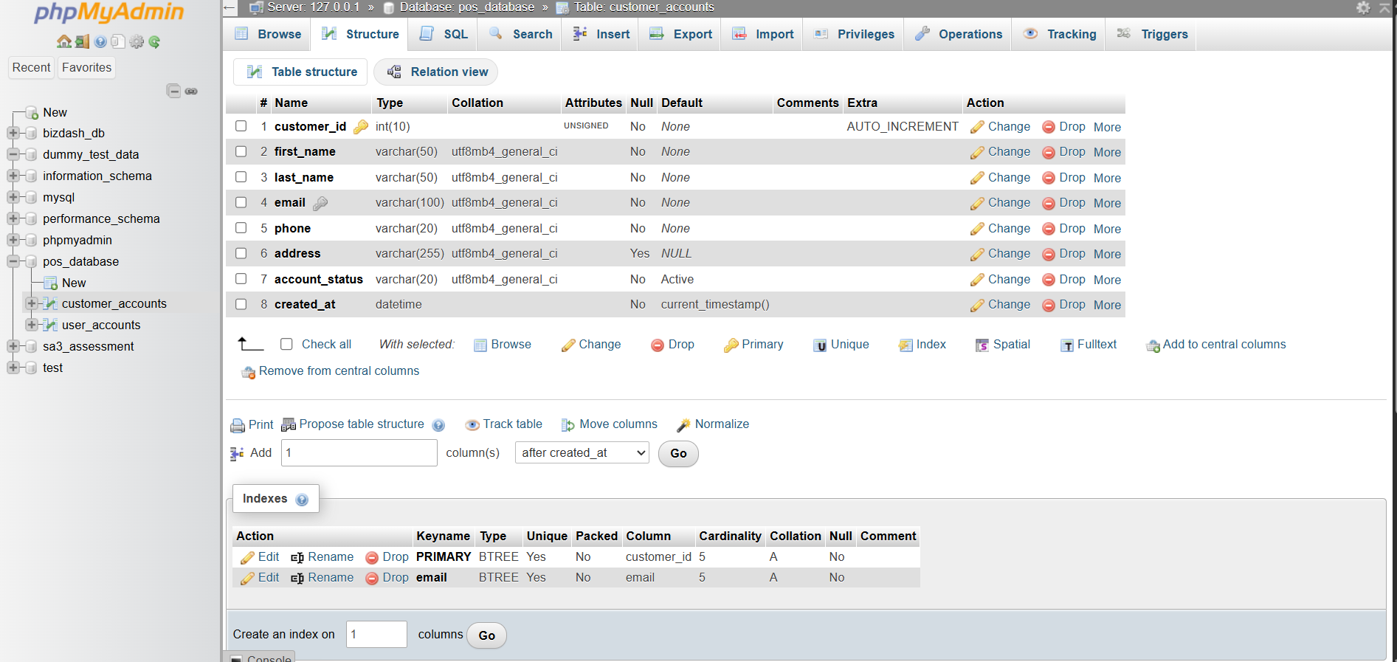
Figure 4 customer_accounts field types, primary key, auto increment, and unique email index

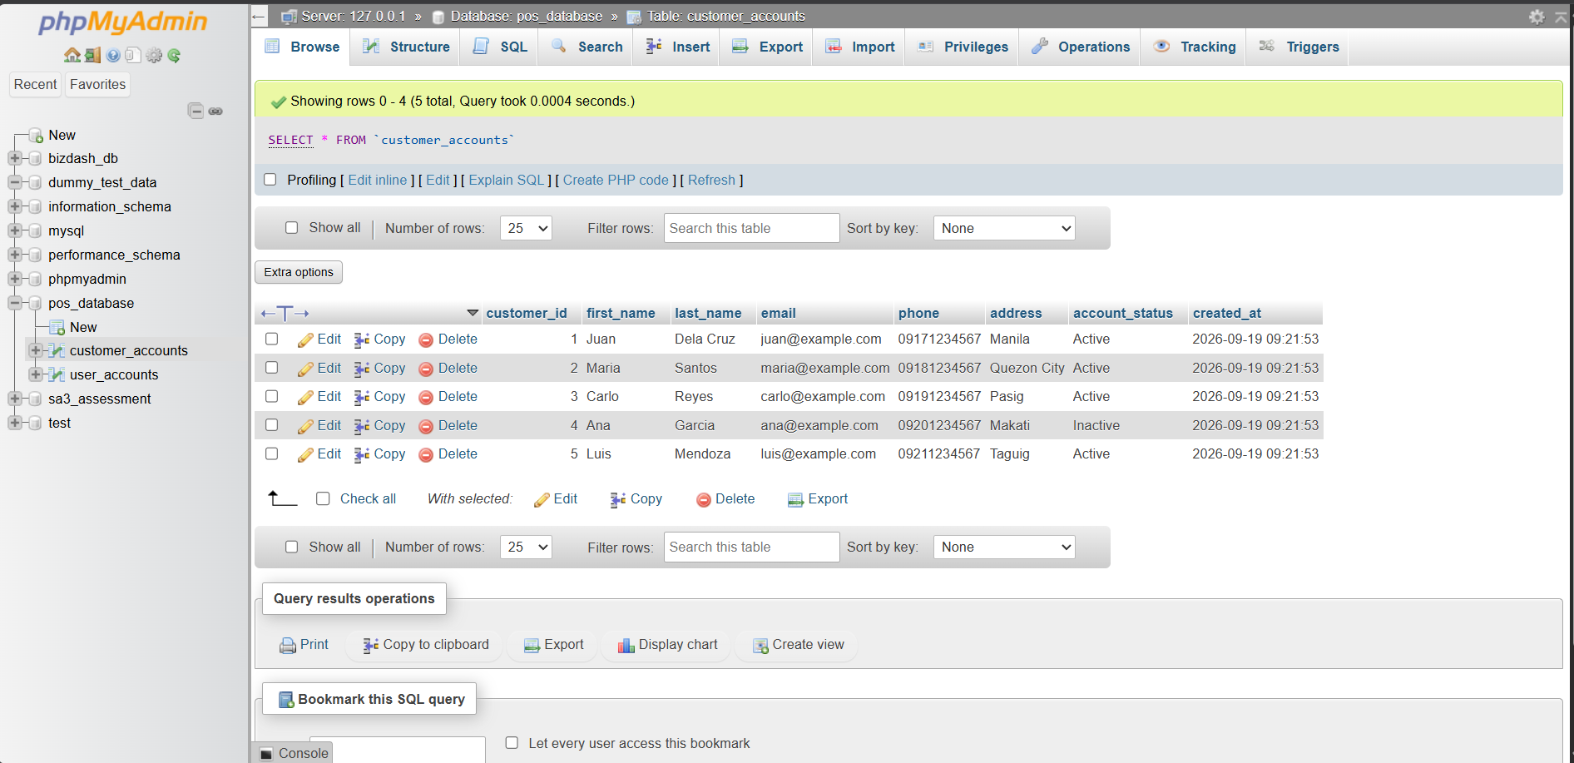
Figure 5 Five customer account records in phpMyAdmin
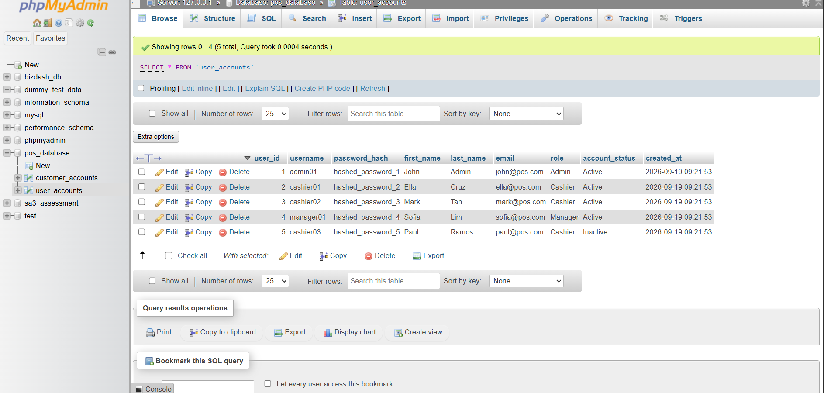
Figure 6 Five user and staff account records in phpMyAdmin

